System Programming

-Gaurav Suryawanshi

# Microprocessor

Masm: Microsoft Macro Assembler

To execute commands do

**Name Command Operand**

## Registers

### Data Registers

Four 32 bit data registers are EAX,EBX,ECX & EDX.

Four 16 bit data registers are there namely: AX, BX, CX, DX where

AX: 16 Bits is comprised of

|  |  |
| --- | --- |
| AH | AL |
| 8 bits | 8 bits |

Similarly, BX (16 bits) is comprised of

|  |  |
| --- | --- |
| BH | BL |
| 8 bits | 8 bits |

Hence, in total

|  |  |  |  |
| --- | --- | --- | --- |
| 16 Bit | 8 Bit Registers | Values | Remarks |
| AX | AH+AL | AH=AX/256  AL=AX%256  AX=AH*256+AL | **Accumulator**;  Ax is preffered for Arithmetic and data transfer. I/O |
| BX | BH+BL | BH=BX/256  BL=BX%256 | **Base**  Serves as address for table lookup |
| CX | CH+CL | CH=CX/256  CL=CX%256 | **Count**  Looping |
| DX | DH+DL | DH=DX/256  DL=DX%256 | **Data**  Used in Mul/DIV. Used in I/O |

### Segment Registers

Four Segment Registers

|  |  |  |
| --- | --- | --- |
| Register name | Bits | Function |
| CS | 16 | **Code Segments**  Stores address of Code segment |
| DS | 16 | Data Segments |
| SS | 16 | Stack Segments |
| ES | 16 | Extra Segment |

### Pointer And Index Register

All Registers are 16 Bits

|  |  |  |
| --- | --- | --- |
| **Operand** | **Name** | **Remarks** |
| SP | Stack Point | Used for accessing Stack Segment |
| BP | Base Pointer | Used for accessing data from stack segment |
| SI | Source Index | Used to point to memory location in the data segments addressed by DS |
| DI | Destination Index | Same as SI |
| IP | Instruction Pointer | Contains the offset address of the next instruction to be executed |

### Flag Register

16 Bit Register containing Various Flags like status and control flags

|  |  |  |  |  |  |  |  |  |  |  |  |  |  |  |  |
| --- | --- | --- | --- | --- | --- | --- | --- | --- | --- | --- | --- | --- | --- | --- | --- |
| 15 | 14 | 13 | 12 | 11 | 10 | 9 | 8 | 7 | 6 | 5 | 4 | 3 | 2 | 1 | 0 |
|  |  |  |  | OF | DF | IF | TF | SF | ZF |  | AF |  | PF |  | CF |

|  |  |  |
| --- | --- | --- |
| **Operand** | **Name** | **Remarks** |
| CF | Carry Flag | CF=1, If there is any carry out from MSB on addition/sub |
| PF | Parity Flag | PF=1, IF the low byte of a result has an even no’s of 1 bit, otherwise 0 |
| AF | Auxiliary Flag | AF=1, If there is a carry out from bit on addition/ subtractions otherwise AF=0 |
| ZF | Zero Flag | ZF=1 for zero result otherwise ZF=0 |
| SF | Sign Flag | SF=1 if MSB of result it 1  Otherwise SF=0 |
| OF | Overflow Flag | OF=1 if sign overflow occurs  Otherwise OF=0 |
| DF | Direction Flag | DF=0, SI & DI proceed in increasing memory address  DF=1, decreasing |

# Variables

Execution:

Var_name Command Values

|  |  |  |
| --- | --- | --- |
| Command | Meaning | Bits |
| DB | Define Byte | 8 |
| DW | Define Word | 16 |
| DD | Define Double Word | 32 |
| DQ | Define QuadWord | 64 |
| DT | Define 10 bytes | 80 |

Eg: ALPHA DB 4  
BY DB ? ;For Value Not initialized  
WRD DW 2;Initialized to 2  
B_arr DB 10H,20H,30H; Stored as B_arr, B_arr+1 & B_arr+2  
B_arr DW 10H,20H,30H; Stored as B_arr, B_arr+2 & B_arr+4  
string DB ‘ABC’; A=string, B=String+1 …   
msq DB ‘Hello’,ODH,OAH,‘$’; H,E,L,L,O,ODH,OAH,$

## Constants

Exectution:

Var_name EQU Values

# Program Structure

The Model Structure is as follows

.MODEL Small  
.STACK 100H  
.DATA  
;Define Data  
.CODE  
somefn PROC  
 ;Define fn  
somefn ENDP  
MAIN PROC

;Instructions  
MAIN ENDP  
END MAIN

## .MODEL memory_model

|  |  |
| --- | --- |
| Memory_model | Remarks |
| SMALL | Code in 1 segment  Data in 1 Segment |
| MEDIUM | Code in multiple segments  Data in 1 |
| COMPACT | Code in 1  Data in multiple |
| LARGE | Code in multiple  Data in multiple  Array size max = 64kb |
| HUGE | Code in multiple  Data in multiple  Array size max >64kb |

## .DATA

Variables are declared here, as previously discussed

## .STACK

.STACK size

Eg .Stack 100h

## .CODE

For writing Code to solve any problem

# Procedures

Similar to the function in c++. Structure is as follows

Name PROC type  
;Body of Procedure  
RET  
Name ENDP

;For calling  
Call Name

Here,

* Type
  + Near: The statement that calls the procedure is in the same segment as the procedure. *Default* value.
  + Far: Calling statement is in the different segment
* Return: Returns back to calling place.
* Call: Calls the function. It does 2 operations
  + The return address of the calling proc is saved in top of the stack. This is the offset address of next instruction to be executed, after proc is completed.
  + IP(instruction pointer) gets the offset address of the first instruction of the procedure.

# Arrays

## 1-D Array

Eg are

* MSG DB ‘HELLO$’
* W DW 10,20,30,40,50
* GAMMA DW 100 DUP(?)
* DELTA DB 212 DUP(?)
* LINE DB 5,4,2 DUP(2,3DUP(0),1) ;{5,4,2,0,0,0,1,2,0,0,0,1}

### Addressing Modes

#### Register Mode

[register]

Is used to call the reference. However, this is only restricted to few registers.

|  |  |
| --- | --- |
| BX,SI,DI | DS |
| BP | SS |

Eg:

* MOV AX, [SI] ;Moves the content addressed by SI to AX
* MOV BX,[BX] ;Content of address BX into BX

#### Based and Indexed Addressing mode

### 

[reg.+displacement]

[displacement+reg.]

[reg]+displacement

Displacement+[reg]

Registered that can be used is same as previous.

Eg: Let W be a variable. All examples mean the same

* MOV AX, W[BX]
* MOV AX, [W+BX]
* MOV AX, W+[BX]
* MOV AX, [BX]+W

#### PTR

type PTR address_expression

Here Types are either BYTE or WORD.

It is used to override the declared type of expression-

Eg

* DOLLAR DB 1AH

CENT DB 52H

…

MOV AX,DOLLAR ;Wrong

MOV AX, WORD PTR Dollar ;Right

#### Accessing elements in the stack

Eg

* MOV BP, SP
* MOV AX, [BP]
* MOV BX, [BP+2]
* MOV CX, [BP+4]

## 2-D Array [A]mxn

Eg

* B DW 10,20,30,40

DW 50,60,70,80

DW 90,100,311,121 ;Row Major order A+[(i-1)N+(j-1)]S; S is the size (2 for W, 1 for B)

* B DW 10,20

DW 50,60

DW 90,100 ;Column Major order A+[(i-1)+(j-1)M]S

### Addressing mode

#### Base-Index mode

Variable[base_reg][index_reg]

What it does is gets info, after shifting the origin to Variable[Base_reg] and adds offset of index_reg. So A[4][3]==A[7]

# String

|  |  |  |  |
| --- | --- | --- | --- |
| *Instruction* | *Command* | *Destination* | *Source* |
| Move String | MOVSB | ES:DI | DS:SI |
| Compare String | CMPSB | ES:DI | DS:SI |
| Load String | LODSB | AL or AX | DS:SI |
| Scan String | SCASB | ES:DI | AL or AX |
| Store String | STOSB | ES:DI | AL or AX |

# Macros

A procedure is called at execution time, control transfers to the procedure and returns after executing Its statements. A macro Is invoked at assembly time. The assembler copies the macro's statements into the program at the position of the invocation. When the program executes, there is no transfer of control.

Macro_name MACRO d1,d2 … dn

;Statements

ENDM

;Bunch of shit

Macro_name d1,d2 … dn

Where d1,d2 … is the dummy list of arguments used by the macro

## Local Psuedo-op

A macro with a loop or decision structure contains one or more labels. If such a macro Is Invoked more than once in a program, a duplicate label appears, resulting in an assembly error: This problem can be avoided by using local labels in the macro. To declare them, we use the LOCAL pseudo-op, whose syntax Is

LOCAL list_of__labels

## Rept Macro

The REPT macro can be used to repeat a block of statements.

REPT expression

;Statements

ENDM

## Indefinite Repeat

IRP d, <a1,a2,…,an>

;Statements

ENDM

## Conditionals

CONDITIONAL

;Statements

ELSE

;Statements

ENDIF

### List of Conditional

|  |  |
| --- | --- |
| **Form** | **True if** |
| IF exp | Constant expression is non-zero |
| IFE exp | Constant expression is zero |
| IFB <arg> | Argument is missing |
| IFNB <arg> | Argument is not missing |
| IFDEF <sym> | Symbol sym is defined in the program (or as extern) |
| IFNDEF <sym> | Symbol sym is not defined in the program (or as extern) |
| IFIDN <string1> <string2> | String1 and string2 are identical. Brackets are require. |
| IFDEF <string1>, <string2> | Are different |
| IF1 | Assembler is making the first assembly pass |
| IF2 | Assembler is making the second assembly pass |

# Memory Management

.COM : has one segment only. ORG 100h is used for stack no need for @data lines.

## Program Modules

### Near v/s Far

A procedure ls NEAR if the statement that calls it is in the same segment as the procedure itself; a procedure is FAR if it Is called from a different segment.

FAR procedure Is In a different segment from Its calling statement, the CALL instruction causes first CS and then IP to be saved on the stack, then CS:lP gets the segment offset of the procedure. To return, RET pops the stack twice to restore the original CS:IP.

### Extern

When assembling a module, the assembler must be Informed of names which are used In the module but are defined In other modules, otherwise these names will be flagged as undeclared.

EXTERN external_name_list

Here, external_name_list ls a list of arguments of the form name:type where name ls an external name, and type Is one of the following: NEAR, FAR, WORD, BYTE, or DWORD.

### Public

A procedure or variable must be declared with the PUBUC pseudo-op if it is to be used in a different module

PUBLIC external_name_list

## Full Segment Definations

With the full segment definitions, the programmer can control how segments arc ordered, combined with each other, and aligned relative to each other In memory

### Segment Directive

name SEGMENT align combine class  
 ;Statements  
name ENDS

#### Align Type

The align type of a segment declaration determines how the starting address of the segment is selected when the program is loaded in memory.

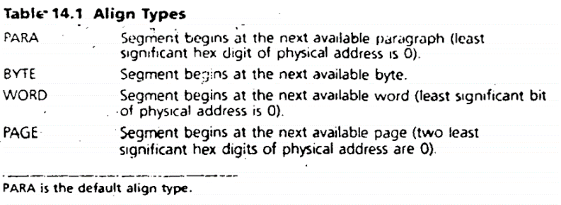

#### Combine type

If a program contains segments of the same type, the combine type tells how they are to be combined when the program is loaded in memory.

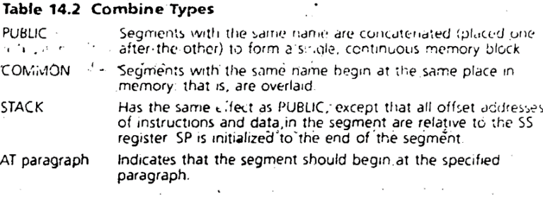

#### Class Type

The *class* type of a segment declaration determines the order in which segments are loaded in memory. Class type declarations must be enclosed in single quotes. If two or more segments have the same class. they are loaded in memory one after the other. If classes are not specified in segment declarations segments are loaded in the order, they appear in the source listing.

# Floating Point Representation

In the floating-point representation, each number is represented in two parts: a mantissa, which contains the leading significant bits in a number, and an exponent, which is used to adjust the position of the binary point. For example, the number 2.5 in binary is 10.1b, and its floating-point representation has a mantissa of 1.1 and an exponent of 1. This is because 10.1b can he written as 1.01 x 21. Negative exponents are not represented as signed numbers. Instead, a number called the bais is added to the exponent to create a positive number. For example, if we use eight bits for the exponent, then the number (27 - 1) or 127 is chosen as the bias. To represent the number 0.0001b, we have a mantissa of 1.0 and an exponent of -4. After adding the bias of 127, we get 123 or 0111110 I b. It starts with a sign bit, followed by an 8-bit exponent, and a 23-bit mantissa. For short real figure 18.1 is represented

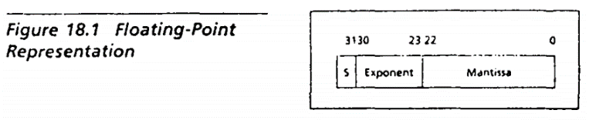

## 8087 Stack

The 8087 has eight 80-bit data registers, and they function as a stack. Data may be pushed or popped from the stack. The top of the stack is addressed as ST or ST(0). The register directly beneath the top is addressed as ST(1). In general, the ith register in the stack is addressed as ST(i), where I must be a constant. Data types in 8087 are

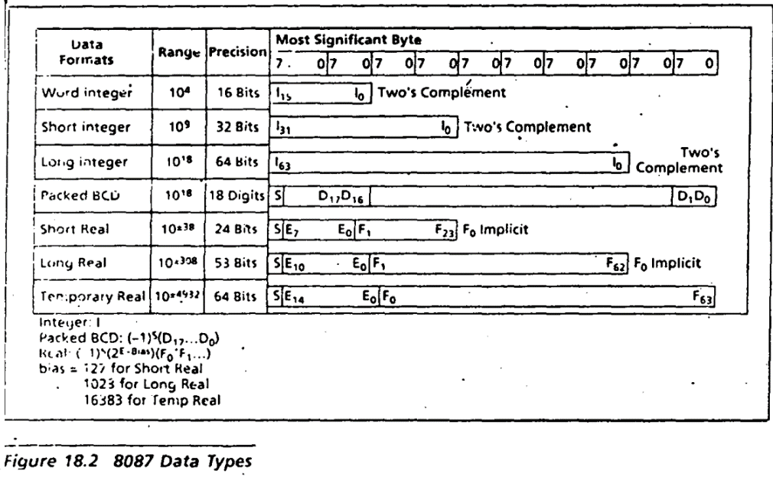

# Intel instruction Format

|  |  |  |
| --- | --- | --- |
| Type | Bytes Required | Example |
| Prefix | 0-4 Bytes | *Deals With Instruction behaviour*  Operand Size Override  Address Size Override |
| O/P Code | 1 Byte | Not: 0011011w |
| Mod R/M | 1 Byte | Modregreg  Instructions like ADD  ADDregreg |
| SIB | 1 Byte | Scale Index Base |
| Displacement | 1 or 2 Bytes | Initial address |
| Immediate | 1 or 2 Bytes | Numerical input  MOV AX,25 |

## Data Storage Buffer



## Types of Record

|  |  |  |
| --- | --- | --- |
| Type | Prefix | Use |
| Header | H | Header type record, kind of stores the name of the file |
| Reference | R | External Reference storage |
| DAT type | D | Is used when the address has to be changed relative to initial address |
| Memory type | M | A variable or the procedure which has been used in the code but memory is unknown |

# **Important Commands**

|  |  |  |  |
| --- | --- | --- | --- |
| Command Name | Syntax | Eg | Remarks |
| ASCII Adjusted Addition | AAA | MOV AL,6  ADD AL,7  AAA | Used to check for carry in BCD values. Values is stored in AL. It does  AH=AL/10  AL=AL%10 |
| ASCII Adjusted Multiplication | AAD | AAD | AL=AL+10*AH  AH=0 |
| ASCII Adjusted Multiplication | AAM | AAM | Same as above |
| ASCII Adjusted Subtraction | AAS | MOV AL,6  SUB AL,7  AAS | Used to check for carry in BCD values. Values is stored in AL. It does  AH=AL/10  AL=AL%10 |
| Add | ADD dest, src/val | ADD AH,2  ADD AH,BX  ADD Word1,AX | Dest=dest+src/val |
| Add with Carry | ADC dest, src/val | ADC AX,1  ADC AX,BX | Adds the carry bit along with normal ops |
| And | AND dest, src/val | AND AL,7FH {Clears sign bit of AL} | Can be used to clear specific Bits while reserving others. 7FH stands for DEL. Changes the destination. |
| Convert Byte to word | CBW | CBW | Converts byte to word. Used in DIV/IDIV |
| Clear Direction Flag | CLD | CLD | Clears the direction flag. If 0 then pointer to the data is incremented |
| Compare | CMP dest, src | CMP AX,BX  CMP AX, ‘$’  CMP AX, 5 | Sets flag CF=0 if not equal, CF=1 if equal |
| Compare String byte  Compare String Word | CMPSB  CMPSW |  | subtracts the byte with address ES:DI from the byte with address DS:SI, and  sets the flags. The result is not stored. |
| Convert Word to double word | CWD | CWD | Converts word to double word. Used for IDIV |
| Decrement | DEC dest | DEC BX  DEC AX | Dest -=1 |
| Division | DIV divisor  IDIV divisor | DIV BX  DIV BL | For **DIV** DX=0 (AH=0)  For **IDIV**, DX(AH) should be signed extension. Use CWD.  **Byte:** Divisor is 8-bit register.  AL = AX/divisor  AH = AX%divisor  **Word Form:** Divisor is 16 bit. Dividend is 32 bit DX:AX  AX = DX:AX/div  DX = DX:AX%Div |
| DUP | DUP(values) | DUP(?)  DUP(42) | Fills random value  Fills 42 |
| Load onto 8087 stack | FLD (load real)  FILD (int load)  FBLD (packed BCD load) | FLD source  FILD source  FBLD source | Where Source is a memory location |
| Store 8087 into destination | FST (store real)  FIST (store int)  FSTP (Store real pop)  FISTP (store int pop)  FBSTP (store BCDpop) | FST destination  FIST destination  FSTP destination  FISTP destination  FBSTP destination | Where destination is a memory location |
| Arithmetic on 8087 stack | FADD [[dest,] src]  FSUB [dest, src]  FMUL [dest, src] FDIY [dest, src]  FIADD source  FISUB source  FIMUL source  FIDIV source | Add  Subtract  Mul  Divide  Integer add  Integer subtract  Integer mul  Int div | Each opcode can take zero, one, or two operands. An  instruction with no operands assumes ST(0) as the source and ST(1) as the  destination; the instruction also pops the stack. In an instruction with one operand, the operand specifies a memory location as the source; the destination. is assumed to be ST(0). |
| Increment | INC dest | INC BX  INC AX | Dest +=1 |
| Interrupt | INT 21h | Int 21h | Does when:  **AH=1**: gets ASCII Code of key pressed  **Input:** *AL=ASCII of Key pressed*  **AH=2**: prints single char output  **Input:** *DL=ascii value of char to be printed*  **AH=9**: String output till it encounters ‘$’  **Input**: *DX=offset address of the string* |
| Jump if greater *(signed)* | JG/JNLE | JG K3 | Condition for jump:  ZF=0 & SF=OF |
| Jump if greater than equal | JGE/JNL | JGE K4 | SF=OF |
| Jump if less | JL/JNGE | JL I5 | SF<>OF |
| Jump if less than & equal | JLE/JNG | JLE L4 | ZF=1 & SF <> OF |
| Jump if greater *(unsigned)* i.e Jump if Above | JA/JNBE | JA K4 | Condition for jump:  CF=0 & ZF=0 |
| Jump if above or equal | JAE/JNB | JAE | Condition for jump:  CF=0 |
| Jump if below | JB/JNAE | JB | Condition for jump:  CF=1 |
| Jump if below of equal/not above | JBE/JNA | JBE K3 | Condition for jump:  CF=1 or ZF=1 |
| Jump if equal  *(Single flag Jump)* | JE/JZ | JE | Condition for Jump:  ZF=1 |
| Jump if not equal | JNE/JNZ |  | ZF=0 |
| Jump if carry  Jump if not carry | JC  JNC |  | CF=1  CF=0 |
| Jump if overflow  Jump if not overflow | JO  JNO |  | OF=1  OF=0 |
| Jump if signed  Jump if not signed | JS  JNS |  | SF=1  SF=0 |
| Jump if even parity  Jump if odd parity | JP/JPE  JNP/JPO |  | PF=1  PF=0 |
| Unconditional Jump | JMP | JMP k4 |  |
| Load Effective Address | LEA dest,src | LEA DX, MSG  LEA SI, AX | Loads address of source to Destination |
| Load String | LODSB  LODSW |  | moves the byte addressed by DS:SI into AL. SI is then incremented if DF =  0 or decremented if DF.= 1. |
| Move | MOV dest, src | MOV AH, WORD1  MOV AX,BX  MOV AH, ‘A’ | Both destination and source cannot be memory variable.  MOV Word1,Word2  Won’t work. |
| Move string Byte | MOVSB  REP MOVSB | MOVSB  REP MOVSB | Moves a single byte from DS:SI to ES:DI.  Repeats the command CX number of bytes |
| Move String Word | MOVSW  REP MOVSW | MOVSW  REP MOVSW | SI, DI increase by 2.  CX number of words. |
| Multiplication | MUL source  IMUL source | MUL BX  MUL BL | Unsigned  Signed  In **byte form**:  AX=source*AL  **Word Form**:  DX:AX=source*AX |
| Negation | NEG destination | NEG AX  NEG AH | To negate destination |
| NOT | NOT Destination | NOT K | Changes bit from 0 to 1 and 0 from 1. {If K =1101b NOT K=0010b} |
| OR | OR | OR AL, 81H {Sets the msb and lsb of AL} | OR is used to set specific bit while reserving the others. Changes the source |
| Pop | POP destination | POP AX  POP BX | Destination must be 16 bit. Does 2 operations   1. Pop ->destination 2. SP+=2 |
| PopF | POPF | POPF | Content of top of the stack will be moved to flag register |
| Push | PUSH source | PUSH AX  PUSH BX | Source must be 16 bit. It does 2 operations   1. SP-=2 2. SS:SP |
| PushF | PUSHF | PUSHF | Pushes the content of flag register on top of the stack |
| Rotate and Carry Left | RCL |  | Shifts CF into higher order word |
| Repeat until not equal to  Repeat until equal to | REPNE SCASB  REPE SCASB  REPE CMPSB  REPNE CMPSB | REPNE SCASB | will repeatedly subtract each string byte from AL, update DI, and decrement  CX until there is a zero result (the target is found) or CX = 0 (the string  ends). |
| Roll Left | ROL Dest, bits_shifted | Same as SHL | The ROL instruction shifts each bit to the left, with the highest bit copied in the Carry flag and also into the lowest bit |
| Roll Right | ROR Dest, bits_shifted | Same as SHL | The ROL instruction shifts each bit to the Right, with the lowest bit copied in the Carry flag and also into the highest bit |
| Shift Arithmetic Left | SAL Dest, bits_shifted | SAL reg,CL | Identical to SHL. |
| Subtract with borrow | SBB Dest, Src/val | SBB AX, BX  SBB AX, 13 | Subtracts the carry bit too along with normal subtraction |
| Scan Byte  Scan Word | SCASB  SCASW | SCASB | SCASB subtracts the string byte pointed to by ES:DI from the contents  of AL and uses the result to set the flags.  ZF=0 ;If diff  ZF=1; if same char |
| Shift Arithmetic Right | SHR Dest,Bits_shifted | SAR reg,CL  Same as SHl | The lowest bit is copied to carry flag. And signed bit is copied to right |
| Shift Left | SHL Dest, bits_shifted | SHL reg, CL  SHL mem, CL  SHL reg, imm8  SHL mem, imm8 | The highest bit is moved to carry flag. Fills lowest bit with 0. MSB->CF. |
| Shift Right | SHR Dest, bits_shifted | SHR reg, CL  SHR mem, CL  SHR reg, imm8  SHR mem, imm8 | The lowest bit is moved to carry flag. Fills highest bit with 0. MSB->CF. |
| Set Direction Flag | STD | STD | Sets the direction flag. Pointer is decremented |
| Store String | STOSB  STOSW |  | Moves the content of AL to ES:DI, and inc/dec the pointer according to byte/word. |
| Subtract | SUB dest, src/val | SUB AH,2  SUB AH,BX  SUB Word1,AX | Dest=dest-src/val |
| Test | TEST Dest, src | TEST AH, 01H | Same as and but without changing the source. |
| Exchange | XCHG dest, src | XCHG AH,BL  XCHG AX,WORD1  XCHG AX,BX | Both destination and source cannot be memory variable.  XCHG Word1,Word2  Won’t work. |
| XLAT | XLAT | MOV AL, 5  LEA BX, T1  XLAT  ;This will do AL=[T1+5] | Low operand instruction which is used to convert byte value into another value that comes from byte table. It adds the content of AL to the address in BX and retrieves the value of the address to AL |
| XOR | XOR |  | XOR is used to Compliment specific bits while reserving the others |

# Linker Loader

## Prog A

|  |  |  |  |  |  |
| --- | --- | --- | --- | --- | --- |
| Code | Memory Address | Command | Values at Pass 1 | Value at Pass 2 | Value after Linking |
| PROG A: START 0 |  |  |  |  |  |
| EXTRN SI,BU,SU |  |  |  |  |  |
| LDA #128 | 0000 | 29 | 01 28 | 01 28 | 01 28 |
| LDA SI | 0003 | 02 | Na na | Na na | 30 00 |
| LDA #1 | 0006 | 29 | 00 01 | 00 01 | 00 01 |
| LDX #0 | 0009 | 05 | 00 00 | 00 00 | 00 00 |
| L1: STA BU,X | 000C | 0F | Na na | Na na | 30 06 |
| ADD #1 | 000F | 19 | 00 01 | 00 01 | 00 01 |
| TIZ SI | 0012 | 2C | Na na | Na na | 30 00 |
| JEQ L2 | 0015 | 30 | Na Na | 00 1B | 10 1B |
| J l1 | 0018 | 3C | 00 0C | 00 0C | 10 0C |
| L2: JSUB SU | 001B | 48 | Na Na | Na Na | 20 00 |
| RSUB | 001E | 4E | 00 00 | 00 00 | 00 00 |
| END |  |  |  |  |  |

### Tables for Prog A

|  |  |  |
| --- | --- | --- |
| Type | Name | Address |
| H | PROG A |  |
| R | SI |  |
| R | BU |  |
| R | SU |  |
| D |  | 000C |
| D |  | 0015 |
| M | SI | 0004 |
| M | BU | 000D |
| M | SI | 0013 |
| M | SU | 001B |

## Prog B

|  |  |  |  |  |  |
| --- | --- | --- | --- | --- | --- |
| Code | Memory Address | Command | Values at Pass 1 | Value at Pass 2 | Value after Linking |
| PROG B: START 0 |  |  |  |  |  |
| PUBLIC SU |  |  |  |  |  |
| EXTRN SI,BU,TO |  |  |  |  |  |
| SU: LDA #0 | 0000 | 29 | 00 00 | 00 00 | 00 00 |
| LDX #0 | 0003 | 05 | 00 00 | 00 00 | 00 00 |
| L3: ADD BU,X | 0006 | 1B | Na na | Na na | 30 06 |
| TIX SI | 0009 | 2C | Na na | Na na | 30 00 |
| TEQ L4 | 000C | 30 | Na na | 00 12 | 20 12 |
| TE L3 | 000F | 30 | 00 06 | 00 06 | 20 06 |
| L4: STA TO | 0012 | 0C | Na na | Na na | 30 03 |
| RSUB | 0015 | 4F | 00 00 | 00 00 | 00 00 |
| END |  |  |  |  |  |

### Tables for Prob B

|  |  |  |
| --- | --- | --- |
| Type | Name | Address |
| H | PROG B |  |
| R | SI |  |
| R | BU |  |
| R | TO |  |
| D |  | 000D |
| D |  | 0010 |
| D | SU | 0000 |
| M | BU | 0007 |
| M | SI | 000A |
| M | TO | 0013 |

## Prog C

|  |  |  |  |  |  |
| --- | --- | --- | --- | --- | --- |
| Code | Memory Address | Command | Values at Pass 1 | Value at Pass 2 | Value after Linking |
| PROG C: START 0 |  |  |  |  |  |
| PUBLIC SI, BU, TO |  |  |  |  |  |
| SI DB 1 | 0000 | 29 | Na na | Na na | Na na |
| TO DB 1 | 0003 | 05 | Na na | Na na | Na na |
| BU DB 50 | 0006 | 1B | Na na | Na na | Na na |
| END |  |  |  |  |  |

### Tables for Prog C

|  |  |  |
| --- | --- | --- |
| Type | Name | Address |
| H | PROG C |  |
| D | SI | 0000 |
| D | TO | 0003 |
| D | BU | 0006 |

## Linker Table

|  |  |  |  |
| --- | --- | --- | --- |
| Program Name | Load Point | Label | Absolute Adress |
| PROG A | 1000 |  |  |
| PROG B | 2000 |  |  |
|  |  | SU | 2000 |
| PROG C | 3000 |  |  |
|  |  | SI | 3000 |
|  |  | TO | 3003 |
|  |  | BU | 3006 |